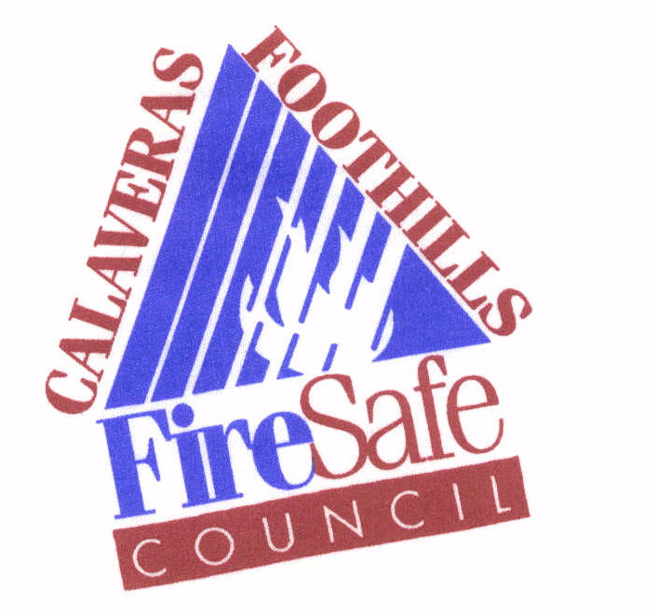
Calaveras Foothills Fire Safe Council
P.O. Box 812
Murphys, CA 95247

REQUEST FOR PROPOSALS
FOR CONTRACTED SERVICES TO THE
CALAVERAS FOOTHILLS FIRE SAFE COUNCIL

RELEASE DATE: | April 29, 2024
CLOSING DATE: | Proposals must be mailed to the address below and postmarked no later than May 20, 2024
PROJECT TITLE: | Seniors and Disabled Defensible Space Program
CONTACT PERSON:
Bill Fullerton
Project Coordinator
Calaveras Foothills Fire Safe Council
P. O. Box 812
Murphys, CA 95247
(209) 728-8785
Email: info@calaverasfiresafecouncil.org
INTRODUCTION
The Calaveras Foothills Fire Safe Council, herein referred to as the (CFFSC) has received grant funding from Pacific Gas and Electric. The purpose of this grant is to plan and perform strategic fuels reduction and to reduce the threat of catastrophic wildland fire to communities in Calaveras County, California. This area is identified as a high priority fuels reduction area in the Calaveras County Community Wildfire Protection Plan.
BACKGROUND
Many communities in Calaveras County have been identified as Communities at Risk in the Federal Register. Even though PRC 4291 rules have been in place for many years, however, many of our residences still have not brought their homes up to par with current State regulations regarding defensible space around their homes.

PROPOSAL
This project will provide fuels reduction work that will include but not be limited to guidelines addressed by Cal-Fire regarding 100’ defensible space (PRC 4291).
RESPONSIBILITIES / SCOPE OF WORK
Seniors and Disabled Defensible Space:
Contractor will perform fuels reduction work necessary to comply with the latest 100’ defensible space guidelines as defined by Cal-Fire. Project scope does not include large diameter tree felling. Materials 9” in diameter or less may be removed to follow current guidelines. All fuels reduction work will be done by hand, no mechanized equipment such as masticators shall be used. Once fuels reduction work has been completed, materials shall be chipped. All materials deemed appropriate shall be cut into firewood lengths as per request of homeowner. Chipping redistributes forest vegetation that is cut by mechanical or hand thinning. The chips may be scattered throughout the project area at a depth no greater than 3 inches or in piles for later distribution by homeowner. The only material that will be hauled away by the contractor shall be materials not suited for the chipper.
Other responsibilities of the Contractor include:
- Contractor will not chip during known Red Flag Days or after being contacted by the CFFSC to shut down work due to severe fire danger.

- Contractor will work with the CFFSC to ensure compliance with the guidelines, conditions, and criterions of the grant.

- Contractor will include enough layout time and supervision time in bid to assure public safety and compliance with property owner and CFFSC requirements.
- Contractor will be sensitive to and responsive to property owner's desires within the objectives of the Grant and this contract.
- Contractor will be responsible for crew's safety and sanitation needs.
- Contractor shall comply with all established administrative processes (monthly contractor's reports and invoicing) of the CFFSC. Payments will be made within 30 days of approval by the Project Coordinator of invoices submitted by the Contractor.
- Contractor shall attend site visits to evaluate property and estimate time needed to complete property.

- Contractor shall take before and after digital pictures of atleast 10 job sites.
- Contractor will be responsible for all scheduling of work and homeowner notifications.

- Contractor will protect any areas from disturbance that have been identified as an archaeological site, endangered plant or animal habitat, or watercourses. These areas, if any, will be discussed at the pre-operations meeting and will be flagged with orange and black striped flagging as equipment exclusion zones.
- Contractor will be responsible for ensuring protection of structures, property improvements, power lines and other utilities.
- Work under this Agreement shall be completed no later than November 20, 2024. The work is planned to occur between June 2024 and November 20, 2024.

- Contractor will complete applications within 30 days of receipt unless agreed upon by the CFFSC representative due to high number of applications or other unforeseeable events that delay operations.
EVALUATION
Members of the CFFSC and the Project Coordinator will evaluate contractors’ performance.
AVAILABLE FUNDS
The maximum amount of funds available for contracted services in this grant is $85,000.00. The selected candidate must acknowledge and affirmatively indicate that he/she can provide the tasks outlined in the Scope of Work within this amount.

PROPOSAL FORMAT
A qualifying proposal must address all the following items:
- Cover Sheet with the following information:
  - Title of Proposal
  - Name and Address of Company
  - Contact person, Telephone Number and Fax Number.
- Understanding of the Project: The contractor shall provide a brief response that demonstrates an understanding of the project parameters.
- Approach and Objectives: The contractor shall briefly outline how their proposal will be responsive to the Scope of Work.
- Qualifications of Key Personnel: The contractor shall provide the names of the key people who will be working on this project, their role in the project, and a synopsis of their experience relevant to these roles. Expertise in the development of fuel breaks is highly desirable.
- References: The contractor shall provide a minimum of three recent references from similar or related projects, including an appropriate contact name, telephone number and e-mail address (if available).
- Cost Proposal: The contractor shall provide a daily cost that covers all work and responsibilities described in the Project Description and Scope of Work.
- Driving Record and Insurance: Contractor must maintain a valid driver's license. The successful applicant must provide proof of current auto, liability, and workmen's compensation insurance.
  - Commercial Automobile Liability Insurance of not less than $500,000 is required in the event motor vehicles are used by the Contractor. One million dollars ($1,000,000) per accident for bodily injury and property damage combine single limit.
  - Worker’s Compensation coverage: Contractor shall maintain workers' compensation insurance for all its employees.
  - Commercial General Liability Insurance of not less than One Million dollars ($1,000,000) combined single limit per occurrence for personal injury liability, bodily injury, and property damage. One million dollars ($1,000,000) aggregate.

PROPOSAL SUBMISSION
Proposals must be emailed to the Calaveras Foothills Fire Safe Council at info@calaverasfiresafecouncil.org and postmarked no later than May 20, 2024. Receipt of the proposal will be acknowledged via email. No proposals will be accepted after this deadline. Address any questions to the contact person listed on the first page.
NONDISCRIMINATION
The program or activities conducted under this agreement will be in compliance with the nondiscrimination provisions contained in Titles VI and VII of the Civil Rights Act of 1964, as amended; the Civil Rights Restoration Act of 1987 (Public Law 100-259); and other nondiscrimination statutes: namely, Section 504 of the Rehabilitation Act of 1973, Title IX of the Education Amendments of 1972, the Age Discrimination Act of 1975, and the American's with Disabilities Act of 1990. They will also be in accordance with regulations of the Secretary of Agriculture (7CFR-15, Subparts A & B), which provide that no person in the United States shall on the grounds of race, color, national origin, gender, religion, marital or family status, be excluded from participation in, be denied the benefits of, or be otherwise subjected to discrimination under any program or activity receiving federal financial assistance from the U.S. Department of Agriculture or any agency thereof.

